Centralized Cataloging in MORE

Report from the MORE Bibliographic Records and Standards Committee for MORE Directors Council, May 2021

Background
Prior to 2013, each MORE-member library was responsible for finding, adding, and editing bib/title records from outside MORE when theirs was the first holding
In 2013, IFLS developed Shared Services: a program providing full receiving, processing, cataloging, and routing services for participating libraries
Other libraries continued to be responsible for their own records
- Library staff had training opportunities from IFLS and access to MORE-specific documentation, but training was not tracked or required
- IFLS staff performed extensive clean-up work
In 2017, in an effort to better manage overall database quality, libraries chose among four cataloging options:
- Option 1: Employ professional, dedicated cataloging staff
- Option 2: Participate in the IFLS Shared Services program
- Option 3: Employ staff or enlist volunteers with MORE cataloging certification
- Option 4: Help fund a staff member focused on database maintenance (this became the Cataloging and Bibliographic Services [CABS] cataloging-only service from IFLS)
Changes took effect in 2018.
The certification program (Option 3) produced uneven results:
- 21 MORE libraries participated in 2020
- Participants received extensive training and follow-up
- MORE Project Managers spent approximately 20 hours per week on the program, or approximately ¼ of their work week
- Certified catalogers were expected to produce high-quality records in accordance with MORE standards (example of book standards). This is particularly time-intensive for staff whose time and attention are divided
A survey of 237 bibliographic records completed by certified catalogers in 2020 showed:
- 14% with no errors
- 36% with access-related errors, meaning patron access was affected by errors and omissions
- 50% with other errors and omissions
In 2020, MORE Directors Council voted to include a centralized cataloging service in the 2021 MORE Budget, and the program was implemented in 2021. All MORE-member libraries currently fall into one of three categories, based on how bibliographic records are supplied for their materials:
CABS participants: Library staff supply information to IFLS catalogers about materials to be added to their collections, IFLS catalogers create bibliographic records, library staff create and attach item records and complete all material processing.
Shared Services participants: Library staff use Sierra’s Acquisitions module to place orders, materials arrive at the IFLS office to be fully processed and cataloged, items are sent to fill holds or be shelved from IFLS. Shared Services participants pay IFLS for processing services on a cost-recovery basis.
Cataloging Partners: Library staff create bibliographic records for their materials, create and attach item records, and complete all material processing. Cataloging Partners receive a subsidy from IFLS for their cataloging work
Bib records added, Jan. 1, 2021-April 22, 2021: 12,099
- Bib records added for items owned or ordered by a Cataloging Partner only: 1,826
  - Chippewa Falls: 452
  - L.E. Phillips, Eau Claire: 961
  - River Falls: 413
- Bib records added for items owned or ordered by one CABS or Shared Services library only: 3,864
- Bib records added for items owned by Fairchild Public Library only (new MORE library): 232
- Bib records added for shared electronic resources: 3,695
- Bib records added for items owned or ordered by multiple libraries: 2,482
  - Chippewa Falls plus at least one other library: 653
  - L.E. Phillips, Eau Claire plus at least one other library: 1,512
  - River Falls plus at least one other library: 785
2021 costs
- Centralized bibliographic services costs in MORE budget: $142,000
- Centralized bibliographic services costs in MORE budget less “off the top” subsidy from IFLS: $135,441
- IFLS also provided a $1,000 subsidy to each MORE-member library
- Cataloging Partner subsidies from IFLS: $20,000
  - Chippewa Falls: $4,063
  - L.E. Phillips, Eau Claire: $11,605
  - River Falls: $4,332

Survey responses, March-April 2021
- It is easy to integrate centralized cataloging into your workflow
- Records are available when staff need them
- Records are available when patrons need them
- Personalized help is available from IFLS when I need it
- Title records are high-quality
- The cost to my library is reasonable
CABS participants (31 responses)
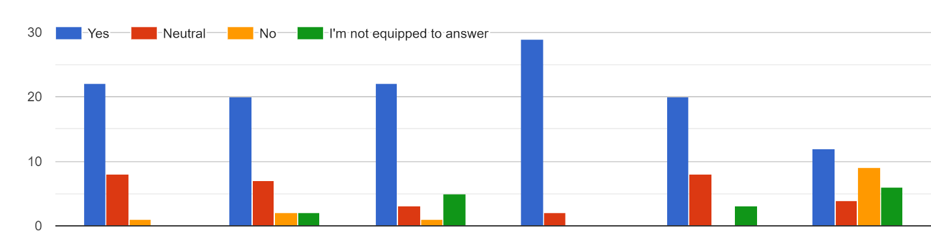
1 2 3 4 5 6

Shared Services participants (8 responses)
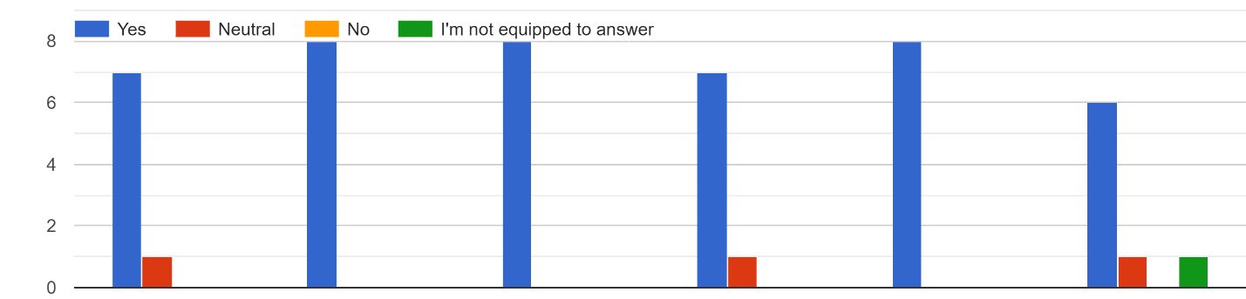
1 2 3 4 5 6

Cataloging Partners (6 responses)
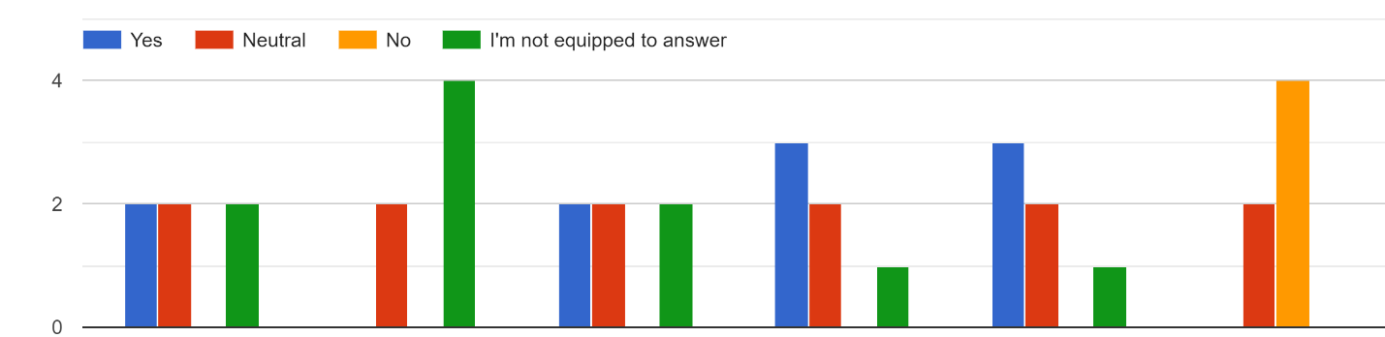
1 2 3 4 5 6

Survey Responses, March-April 2021: Comments about MORE’s centralized cataloging (CABS) service

CABS participants
At this time the cost is reasonable. But with subsequent budgets will it remain so?As this is appproximately $300 more added to our budget, it does make an impact with decreased funding from town and unknown Act 150 $ projection.
CABS is great but, as I have said before, I don't think the one-size-fits-all is a good approach. Some libraries/librarians don't need it or want it, and of course there's no shortage of things that I could spend the money on instead.
Generally CABS works well. The bib records are high quality, although I come across enough records that are missing the 264_4 field that it is noticeable. Previously I could add that field into the record (if I had the item in hand), or fix any other glaring mistakes, such as misspellings. Now I need to email CABS for these corrections taking up both extra time for me and for CABS. CABS staff is always responsive and helpful when I have needed anything (probably because the IFLS staff are awesome people!).
As the person who was cataloging our items previously, however, by the time I finish filling out the information CABS needs for an item I am adding to the collection, I could have had the item cataloged. Therefore, most of the donated items that I would need cataloged by CABS will be sent to CABS, as this is the option that actually takes the least amount of time (taking up less time was supposed to be the big selling point of CABS).
The actual cost to our library for CABS is significantly more than what our director was told that it would be.
Has resulted in budget cuts to collection. I used to do hours of original cataloging each month with no complaints - I miss doing this part of my job.
I absolutely love CABS. I am able to spend more time on Director work instead of searching and then creating a new record. I dreaded that job!
I purchase but don't do anything with the cataloging or processing. Emailing CABS my orders has been very easy.
I think you are doing a great job and have been very helpful to me with the transition.
I'm very torn on CABS. It is not hard to add the extra steps of notifying CABS to my purchasing workflow and the CABS team seems to be doing a good job of course, but we already had a full time tech services staff who was, as I understand it, doing a successful job. It is unfortunate that our library now has to pay for a team of people to do the job she was already doing. However, I also understand that the expanded CABS model is probably best for the good of the whole system since clearly the records in our system were so poor & access to those records is vital.
It works for us!
It would be nice to receive an email notification when item records have been created for donated items. End up handling them multiple times due to CABS.
It's been a great experience working through the kinks and figuring out how to best implement the changes brought about by utilizing CABS services. Thank you for all you do!
Love it - thank you for this service!
love it!
Makes it really easy for staff to learn to attach item records without extensive training.
On the whole, it works pretty well. Do we have a good way to handle items that need a quick turnaround? (ex: the author is giving a presentation here next week, a movie version is coming out soon, it's about an upcoming holiday, it's relevant to an issue that has attention right now in our community, etc)
SO, CABS is the service I chose because I am not a skilled bib record creator. I feel I really only need it in 6 percent of my cataloging, so it is not really cost effective, but it absolutely has its advantages for that 6 percent! I am not crazy about all my Baker and Taylor orders and Micromarketing orders going to CABS for records before they even come to me, because some of the items I purchase are prizes for promotions and games I am doing and now they have order records and show up in the catalog as Luck having the item and we actually don't have it and don't intend to have it. BUT that is just one tiny little thing and overall, it seems to work fine. The staff is really wonderful, but ALL of the MORE staff is really wonderful and about 6 notches above the top tier. I am happy to participate in the CABS program if it can reduce anyone in MORE's workload AND keep the bib police happy. I am all for it.
Some of the records had mistakes that were caught when adding items. Some records contain minor issues. ie the new printing (2010) of the Babysitter series. One patron had trouble locating a book because the additional titles were added to some formats but not others which we assisted her in obtaining the book by searching the author. This was probably an old error. So one of the things that I have learned is not assume that the record is correct until I check it over. However as fewer staff know anything about how to catalog the assumption will be that the record is correct without comparing it to the item in hand. I am sure that CABS is a value for many of the libraries, but in my case i would say no. Which brings up the issue that as catalogers retire will Chippewa Falls, River Falls and Eau Claire replace them or will they shift the work to a service they are already paying for? In which case the cost will continue to go up.
The response time from CABS for help/questions has been extremely fast! The set up was simple and instructions (both written and our zoom with Bridget) were provided. I really value an accurate catalog as I train staff/teach patrons how to use MORE, and I think CABS does a great job. I'm seeing improvements in the catalog already and using CABS has streamlined workflow at Hudson.
The response to needing records was better this past week (March 15th than previously. I believe I am still paying too much for a service I don't really need.
We don't use acquisitions through Sierra, so most of our cataloging is adding items to existing bib records. While we have added bibs, it is very few records; we rarely are the first library to add an original bib record. We found that the records the other libraries (EC, RF, ME, CF, etc) added were of a high quality. We don't feel that we are getting a positive return on investment for the amount we are charged. I don't have the numbers to give an exact amount per item, but what we are currently paying and expect to have to pay next year divided by the number of new bib records we are adding/requesting to have added has to be 100's of dollars per record. I understand that this is to improve the overall catalog and we all benefit from that, but at what cost?
We have it. Some like it better than others. I am being polite.
While my library will likely struggle with the increased cost over time, the value of the CABS service is worth it. Any time I've had to send an e-mail or had an odd-ball item to be cataloged, the entire team has been wonderful and timely. I appreciate their work and know that they're worth it!
While there was/is a learning curve, so far I'm pleased with the service.
Would be helpful to have the CABS procedures in a more prevalent place on the IFLS website.

Shared Services participants
Great service for providing accurate records to our patrons
I am overall satisfied with CABS. We would not be able to do our current volume of cataloging with our budget and staff skills and I really appreciate this service being available to us.
MORE CABS service has greatly improved the overall quality of the database. The increased information in the bib records has created many more access points while patrons are searching for the right book for them. Without the quality records, we spend thousands of dollars on our collection, but they can easily get lost on the shelf and not utilized by patrons across our system.
Very pleased
We love it! I cannot imagine going back to the old way of doing things. Now let's work on centralized ordering.....

Cataloging Partners
As we continue "business as usual," our portion goes towards other libraries services
I haven't really noticed anything different on the acquisitions end of things. Now that I think about it a little, it seems like some order records do seem to have a little more detail (authority authors, titles marked with 1's for authors and cleaned up, Pub dates, and series statements).
I would say, since MORE's cataloging services have expanded, records that are not short order bibs require less review and correction on my part.
Most of the records created by IFLS catalogers are good quality. Some of the audiovisual records require quite a bit of editing because cataloging is often done without the material in hand. Several things I have noticed with book records are missing or incorrect titles, subtitles, edition statements, number of pages, series, and additional content (including discussion questions, bibliographical references, recipes...) This is again because they often catalog without the material in hand. Since it's been only a few months, it's early to evaluate the service.
My workflow has not really changed since CABS started. I am still taking the time to double check each record that IFLS has done and I am finding a lot of things that are incorrect in OCLC getting transferred to Sierra, such as page numbers or title information. I think this is happening because I have the item in hand and can see the things that are not correct. I am also finding a lot of errors with series information. Either the 490 not being linked to 800/830 or 800/830 with no 490 information. Overall I am noticing that the records are much better than before. I am definitely not spending as much time completely fixing records as I was before CABS started.
There has been an overall improvement in record quality, including less short bibs. I do add additional information not present in GHIA records when I catalog them second, particularly additional content (like reader's guides, forewords/afterwords, illustrations, bonus pdf on an audiobook, DVD language tracks, etc.), add missing series statements, fix inaccurate page numbering, etc.

Bib Committee analysis:
- Cataloging trends for public libraries
- Patron experience
- Assessment of alternatives:
  - CABS as opt-in
  - Eliminating CABS
  - Eliminating Shared Services
  - Eliminating Cataloging Partner program
  - Eliminating Cataloging Partner subsidy from IFLS
  - Increased IFLS support for centralized cataloging

Conclusion/recommendation for 2022

